Chapter 8, Solution 63.

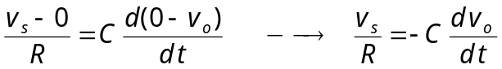
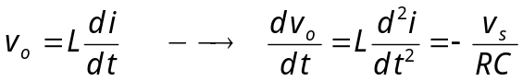
Thus,
